Activities UI

Name : CrudAPi

Revision: 1

Date: 09/18/2020

Author: Rishu Ranjan

For further information please contact:   
  
**Rishu Ranjan**

22rishuranjan@gmail.com

Table of contents

1. Introduction 2

2. Project StRucture 2

3. Components 2

3.1. NavBar 2

3.2. ActivityForm 2

3.3. Activity List 3

3.4. Activity Detail 4

3.5. Activity Dashboard 5

# Introduction

This document provides the technical aspect of the user interface created using React and Typescript.

# Project StRucture

This application uses below packages:

1. *Axios* – to make api call
2. *Semantic-ui* – for styling
3. *Typescript* – to write code
4. *React js* –

# Components

There are mainly 4 components

## NavBar



## ActivityForm

Used to create/edit activity

|  |
| --- |
| Create activity screen Edit activity screen |

### Validation

1. Submit button will be enabled only if title and date field are filled.
2. Submit button will be disabled if there is any validation message on the screen.
3. If lenght >3000, then validation message will be shown.

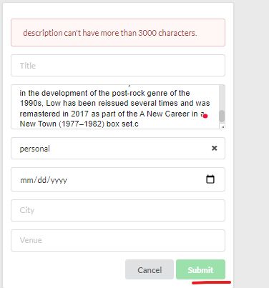

## Activity List

Functionality included:

1. View activity detail
2. Delete activity

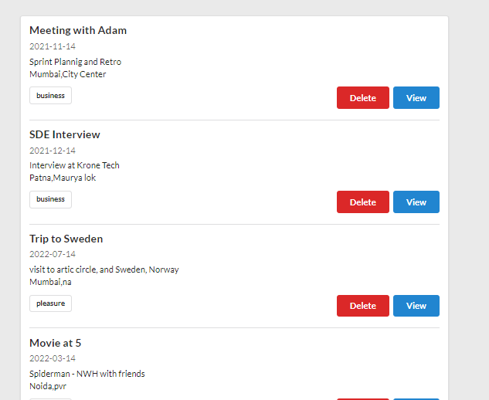

## Activity Detail

Functionality included

1. Edit the Activity Details
2. Cancel current Selected Activity

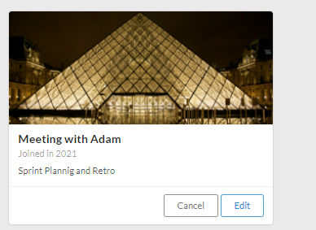

## Activity Dashboard

This contains all the components described above.

